**הסבר על הניסוי (אני כתבתי):**

השפעה לא מודעת של פריים בעל משמעות וחסר משמעות על קבלת החלטות.

נבדקים בוחרים האם לתרום לעמותה או לא.

יש 32 עמותות ונבדקים בוחרים כל פעם לאיזו עמותה מבין 2 לתרום.

יש 4 חלקים לניסוי (זה משתנה type):

* RATING – דירוג עמותות לפי חשיבות אישית, כמה יתרום לכל עמותה. כדי לעודד החלטות קשות.
* Calibration – קליברציה למדידת סף מודעות.

יש PAS.

* Experiment –
  + Forward and backward masking
  + מסכה היא XXXX
  + יש 2 סוגי prime
    - Causes (או npo) – גירוי הקשור לעמותה. זה בעל משמעות.
    - Arrows – חסר משמעות.
  + בחירה לאיזו עמותה מבין 2 תרצה לתרום.
    - החלטה בעלת משמעות – בוחר לאיזו עמותה לתרום 400
    - החלטה חסרת משמעות – בוחר עמותה אחת אך שתיהן מקבלות 200
  + PAS.
* OBJECTIVE –
  + מודד מודעות ל-prime.
  + הפעם הנבדק לא בוחר עמותה, אלא צריך לזהות את הפריים מבין 2 אפשרויות.
  + PAS.

ה-data נמצא ב:

Experiments new 🡪 inbal 🡪 experiment

Good Subs are 101-107

**Aim 2.1: Unconsciously producing preferential bias in arbitrary decision-making**

**Rationale**

This experiment asks if a deliberate process can be affected by unconsciously perceived primes, and if so – could this happen even when the prime doesn’t tap into any decision-related reasons. Accordingly,our research question is threefold: (a) **can deliberate decisions be biased by priming**; (b) **is this bias similar in magnitude to the one found in arbitrary decisions**; (c) **can this bias be evoked by reasons-irrelevant information**.

The methods will be based on the procedure of Maoz et al. (2019): in each trial, subjects were presented with two causes, and asked to press the right/left buttons to indicate their selection. In the current experiment the left and right sides were replaced with up and down due to the left- right political spectrum that can influence responses. Additionally, in the current experiment the targets will be the NPO names while the primes will be the causes to prevent repetition between the prime and target and to prevent selection based on a perceptual similarity. To maximize the chances of getting an effect, we will focus on hard decisions, so that the difference in preference for the two causes – as rated by the subject in a previous session - will be of one point. Half the trials will be deliberate, where subjects’ choice could lead to an actual monetary donation of **₪**400 to the selected NPO. The other half will be arbitrary, where both NPOs would get **₪**200, irrespective of subjects’ response.

In Experiment 1, Unbeknown to subjects, one of the cause names will be subliminally presented prior to presenting the two alternatives. In Experiment 2, an arrow pointing either up or down will be subliminally presented prior to presenting the two alternatives. In both experiments, subjects’ tendency to select the primed NPO will be measured (both with respect to percentage of chosen NPO, and to subjects’ reaction times when selecting the primed vs. the unprimed option). Note that we are focusing on unconscious priming to avoid strategic behavior by the subjects following a conscious prime (and given that the research questions here are not focused on conscious vs. unconscious priming).

**Methods**

Procedure

**Rating session**. In the first part of the experiment, subjects will be presented with 32 NPOs. They will be instructed to rate how much they would like to support each NPO with a **₪**400 donation on a scale of 1 (“I would not like to support this NPO at all) to 7 (“I would very much like to support this NPO”). No time pressure will be put on the subjects, and they will be given access to the website of each NPO to give them the opportunity to learn more about the NPO and the cause it supports.

**Calibration session.** Prior to the experimental session, a near-threshold contrast level (determined as transparency on a scale of 0 (completely transparent) to 1 (not transparent at all) will be determined using a double staircase calibration procedure (Schurger, Cowey & Tallon-Baudry, 2006). We will start with contrast values of 0.6 for both prime and mask, and either increase or decrease the contrast based on performance; the first contrast manipulations will be done on the mask (i.e., increasing or decreasing its contrast). If the contrast of the mask reaches 1, the algorithm will move to manipulating the contrast of the prime, until 10 reversals are obtained. The calibration will begin with a binary search in order to find an approximate threshold (12 trials)- starting with a large step size of 0.3, then cutting it in half on each iteration until reaching a minimum step size, and then, in order to determine the exact near-threshold level (>90% unaware), it will continue with a standard staircase algorithm (reducing the contrast upon stimulus detection and increasing it upon missing the stimulus) with a small step size (88 trials). The aim is to get to approximately 10 reversals on each staircase. The first stage will determine the approximate threshold in relatively few trials while the second stage will determine the exact threshold using the minimum step size needed.

**Experimental session**. The experiment block will be composed of twenty blocks of nine trials each, so that half the blocks will be deliberate and half arbitrary. Two NPO names that differ in ratings by one point only, will be presented in each trial. In deliberate blocks, subjects will be instructed to choose the NPO to which they would like to donate **₪**400 by pressing the up or down arrow key on the keyboard, using their right hand, for the NPO on the up or down, respectively, as soon as they decided. Subjects will be informed that at the end of each block one of the NPOs they chose would be randomly selected to advance to a lottery. Then, at the end of the experiment, the lottery will take place and the winning NPO will receive a **₪**20 donation. In addition, that NPO will advance to the final, inter-subject lottery, where one subject’s NPO will be picked randomly for a **₪**400 donation. It will be stressed that the donations were real and that no deception was used in the experiment. Thus, subjects will know that in deliberate trials, every choice they make is not hypothetical, and could potentially lead to an actual **₪**420 donation to their chosen NPO.

Arbitrary trials will be identical to deliberate trials except for the following crucial differences. Subjects will be told that, at the end of each block, the pair of NPOs in one randomly selected trial would advance to the lottery together. And, if that pair wins the lottery, both NPOs would receive **₪**10 (each). Further, the NPO pair that would win the inter-subject lottery would receive a **₪**200 donation each. It will be stressed to the subjects that there was no reason for them to prefer one NPO over the other in arbitrary blocks, as both NPOs would receive the same donation regardless of their button press. Subjects will be told to therefore simply press either up or down as soon as they decided to do so.

Each block will start with an instruction written either in dark orange (Deliberate: “In this block choose the NPO to which you want to donate **₪**400”) or in blue (Arbitrary: “In this block both NPOs may each get a **₪**200 donation regardless of the choice”) on a gray background. Color assignment will be counterbalanced between subjects. Short-hand instructions will appear at the top of the screen throughout the block in the same colors as that block’s initial instructions; Deliberate: “Choose for **₪**400” or Arbitrary: “Press for **₪**200 each”.

Each trial will start with a 1s gray screen that will be blank except for a centered, black fixation cross. Then, a 50 ms mask will appear, followed by a 30 ms prime and another 50ms mask. In Experiment 1, the prime will be the name of the corresponding cause of one of the two to-be-presented NPOs, and the mask will be a string of Xs. To make the experiments as perceptually similar as possible, the prime In Experiment 2, will be a simple arrow pointing either up or down, and the mask will be a string of X’s The upper part of the up arrow and bottom of the down arrow will merge with the bottom of the second X and top of the third X, respectively. Then, the two NPOs will appear on the up and down side of the fixation cross (up /down assignments were randomly counterbalanced) and remain on the screen until the subjects report their decisions with a key press up or down arrows on the keyboard for the NPO on the up or down, respectively. If subjects will not respond within 20 s, they will receive an error message and will be informed that, if this trial would be selected for the lottery, no NPO would receive a donation.

To make sure subjects are carefully reading and remembering the NPOs during the experiment, 36 randomly interspersed memory catch-trials will be presented throughout the experiment, 18 for each condition (thus more than one catch trial could occur per block). On such trials, four NPOs will be presented, and subjects will be asked to select the one that appeared in the previous trial. A correct or incorrect response will add or subtract 50 cents from subjects’ total, respectively.

After each trial, a question (‘how well did you see the word\arrow) will appear. The subjects will rate the visibility of the prime using the Perceptual Awareness Scale (Ramsoy & Overgaard, 2004), where 1 is “I didn’t see anything,” 2 signifies “I had a vague perception of something,” 3 represents “I saw a clear part of the image,” and 4 stands for “I saw the entire image clearly.”

**Objective session.** To make sure subjects did not see the primes as they reported, a post-test objective session will be given at the end of the experiment (N=100), in which subjects will be presented with the same sequence of stimuli, but at the end of each trial, instead of making a choice, they will be presented with two causes, and will be asked to determine which of the two was presented during the trial. Then, they will be asked to rate the visibility of the prime using the same PAS. In the arrows experiment subjects will have to determine if the arrow pointed up or down.

**Measures**

1. Tendency to choose the primed NPO – calculated as number of chosen Primed NPOs, divided by the total number of trials. This will be done separately for arbitrary and deliberate trials.
2. Difference in Reaction Times (RTs) – calculated as mean RT in trials in which subjects chose the primed NPO vs. mean RT in trials in which subjects did not choose the primed NPO.

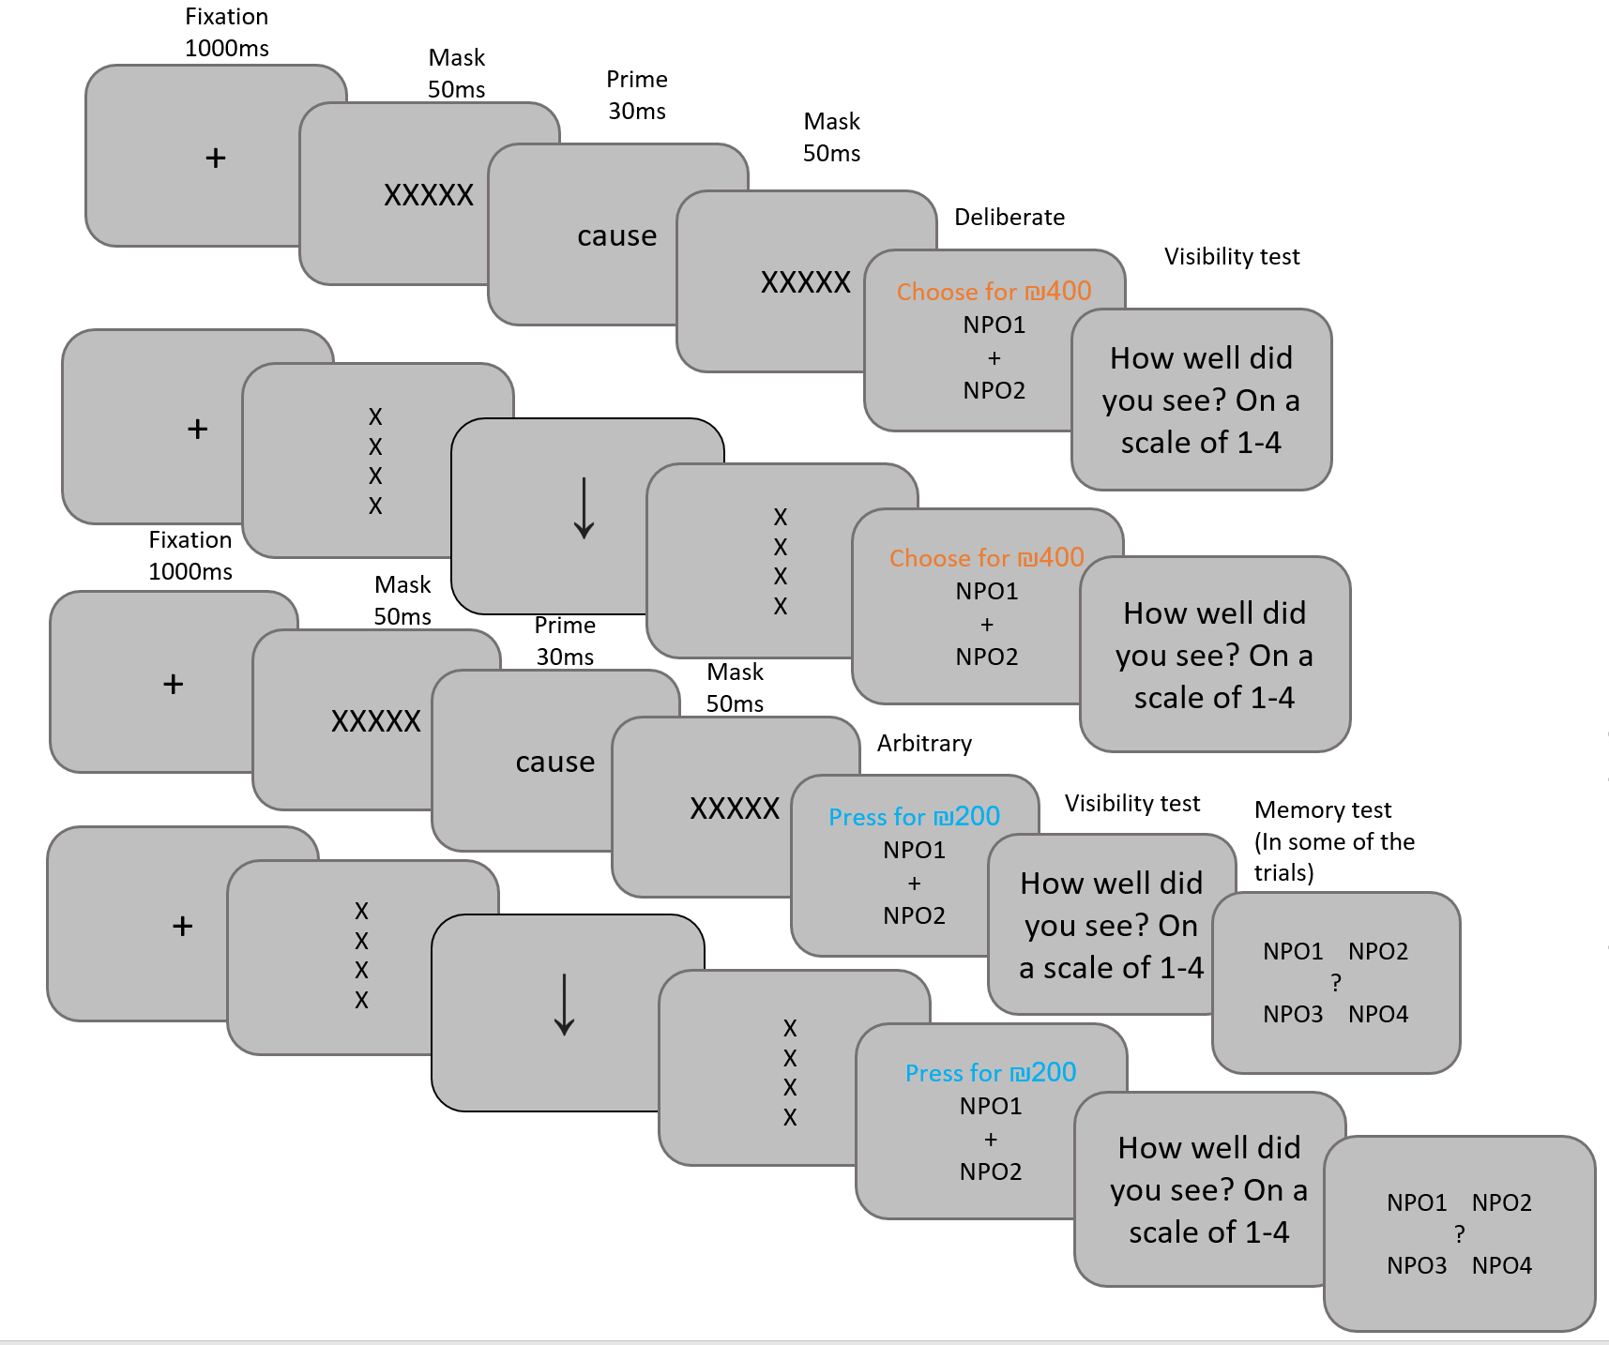

d

c

b

a

Figure 1: Experimental paradigm. The experiment includes deliberate (orange) and arbitrary (blue) blocks, and meaningful primes (cause) and meaningless primes (arrows). Therefore, four conditions are present: (a) deliberate-meaningful, (b) deliberate-meaningless, (c) arbitrary-meaningful (d) arbitrary-meaningless